Understanding the Impact of BERT Layer Freezing on
Accuracy and Speed of Sentimental Analysis
Binamra Aryal, Navjot Gill, Bijay Bastakoti
University of Texas At Arlington

Abstract
This project looks at sentiment analysis on IMDb movie reviews, with a strong focus on making BERT training faster through layer freezing. We first built a simple data cleaning pipeline and a basic CNN baseline to set a starting point. Then we fine-tuned the bert-base-uncased model using several plans. In one plan, we trained every layer. In the other plans, we trained only the top layers and kept the lower layers frozen. Our main goal was to understand the tradeoff between speed and accuracy. We found that freezing the early layers, which teaches general language features, keeps performance close to a fully trained model while cutting training time and computing needs. Partial freezing also made results more stable across different random seeds. In our tests, these frozen setups stayed very close to the accuracy and F1 of a fully trained BERT model and were clearly stronger than the CNN baseline. The project uses a single experiment runner and simple configuration files, which makes every setup easy to repeat. After training, we calibrated the model’s probabilities with isotonic regression, which cut the expected calibration error by about sixty four percent without hurting accuracy. We then mapped the calibrated probabilities to one to five star ratings, which lowered mean absolute error and root mean square error and slightly increased both Pearson and Spearman correlations compared to using raw probabilities. Overall, our results show that smart layer freezing is a practical way to save time and resources while keeping high accuracy.

Code — Submitted on Canvas
Datasets — https://ai.stanford.edu/~amaas/data/sentiment/
Introduction
Sentiment analysis is the understanding of what people feel from what they write, and it is a classic problem in natural language processing. It is used in many places, like seeing how customers react to a product, checking opinions on social media, or summarizing reviews for movies and books. In this project, we focus on movie reviews from the IMDb dataset. Each review is labeled as positive or negative, so it is a clear place to test different models and training choices.
Modern language models like BERT have become very strong at these kinds of problems. BERT learns patterns in language by reading a huge amount of text before we ever use it for a specific task. Then we fine tune it on our task so it can make accurate predictions. The downside is that fine tuning all of BERT can be slow and expensive, especially for people who do not have a lot of GPU power. That is the main issue we want to explore in this work.
Our central idea is to study layer freezing. BERT is built from a stack of layers. The lower layers learn very general language features, like basic grammar and common word relationships. The higher layers learn more task specific features, like what parts of a review signal positive or negative tone. With layer freezing, we keep some of the lower layers fixed and only train the top layers. This can reduce training time and make results more stable, but it might also lower accuracy. We want to measure this tradeoff in a careful way.
To understand the value of layer freezing, we designed a simple but complete pipeline. First, we built a clean preprocessing step that reads the raw IMDb reviews, removes noise such as HTML, and prepares train, validation, and test splits. We kept important text details like punctuation because they often carry emotion. We then trained a basic convolutional neural network as a starting point. This CNN gives us a fair baseline to compare with BERT. After that, we trained several versions of BERT using different freezing plans, from training all layers to training only the top part of the model.
Our goals are straightforward. We want to see how much accuracy we keep when we freeze different numbers of layers. We also want to see how much time and compute we save, and whether frozen models are more stable across random seeds. By answering these questions, we hope to give practical guidance to students and teams who want strong results but have limited resources.
While accuracy is our main metric, we also care about how trustworthy the model’s confidence scores are. A classifier should not only be correct but also honest about how sure it is. After training our best BERT model, we ran it in inference mode to collect raw probabilities for every review in the validation and test sets using torch.no_grad, and we saved these outputs for analysis in compact files. These raw probabilities are often overconfident, so we corrected them with isotonic regression. We fit the calibrator only on validation probabilities and then applied it to the test set. This step made a clear difference: the Expected Calibration Error dropped by about sixty four percent, and the Brier score also improved a little, which means the scores became more reliable without hurting accuracy. With these better probabilities in hand, we moved beyond a simple yes or no label by mapping each probability to a one to five star score using the formula one plus four times p. This solved the gap in the original one to ten ratings and let us compare predictions to true stars in a fair way. The calibrated version gave lower mean absolute error, lower root mean square error, and slightly higher Pearson and Spearman correlations than the uncalibrated version, showing that honest probabilities also carry a clearer signal about sentiment intensity. Together, probability calibration and star rating mapping frame the larger goal of our project: models that are not only accurate but also reliable and useful in real applications.
Another goal is to make the work easy to reproduce. We organized our code with one experiment runner and simple configuration files. This lets us switch models and freezing plans without touching the core logic. It also makes it easy to share our settings and results with others. A clear structure is important for learning and for fair comparisons.
In summary, this project asks a practical question. Can we train BERT for sentiment analysis faster and with fewer resources by freezing some layers, while keeping almost the same accuracy as full fine tuning? We test this on IMDb with a careful setup and a strong baseline. The rest of the report will present the dataset, the models, our training strategy, and a detailed analysis of results, followed by lessons learned, limits, and ideas for future work.
Dataset Description
We use the Stanford Large Movie Review Dataset, often called the IMDb dataset. It was created to study binary sentiment classification on movie reviews. The full release has 25,000 labeled reviews for training and 25,000 labeled reviews for testing, plus a separate set of unlabeled reviews. The data is available as raw text files and also in a ready bag of words form. Each labeled split is balanced, with the same number of positive and negative examples. The creators followed a strict rule to make the task clean: ratings of seven to ten count as positive and ratings of one to four count as negative, while the middle ratings are not used. The labels are tied to the folder names (pos or neg), and the filename stores both a unique ID and the original star rating in the form id_rating.txt.
In its raw form, the dataset is organized as a directory tree. There is a train folder and a test folder, and inside each of these, there are pos and neg folders with thousands of plain text files. Because the data is spread across many files, our first step was to load everything into one master table so we could process it consistently. While doing this, we kept three important pieces of information for each review: the binary label, the original star rating from the filename, and whether it came from the original train or test split. This gave us a clear starting point for later modeling.
Our cleaning philosophy was to remove noise but keep the language signals that carry emotion. We chose not to remove stop words, because words like “not,” “but,” and “never” flip the meaning of a sentence. We also did not do stemming or lemmatization, since different forms of a word can show different shades of feeling. We kept punctuation, especially exclamation points and question marks, because they often show intensity or doubt. Concretely, our pipeline removed HTML tags such as
<br/>, converted text to lowercase, expanded common contractions like “don’t” to “do not,” added spaces around punctuation and emoticons so tokenizers could see them, removed URLs, and collapsed extra spaces. These steps were applied in a fixed order using a series of small, single-purpose cleaners.
To make the workflow reliable and easy to rerun, we organized the preprocessing code into clear modules. A data loader walked the aclImdb folders, read each text file, and parsed the ID and star rating from filenames. A text cleaner applied the sequence of operations described above. A partitioner handled the final splits. A simple front-end script in Colab called a facade class that ran these parts in order and saved the outputs. This structure helped prevent data leaks and kept the original test set untouched.
For modeling, we wanted a separate validation set to tune hyperparameters without touching the final test set. We kept the entire original 25,000 example test split as our held out test data. From the original 25,000 example training split, we made a stratified 90/10 split to create a training set and a validation set, using a fixed random seed so the results are reproducible. This produced three CSV files with the following sizes: 22,500 for training, 2,500 for validation, and 25,000 for testing. Each CSV contains the cleaned text, the binary label, and the original star rating.
We also studied the length of reviews after cleaning to choose a fair maximum sequence length for tokenization. We measured word counts in the cleaned CSVs and found that a limit of 512 tokens covers about nine out of ten reviews across train, validation, and test. In numbers, the training set had an average length of around 264 words, a median of around 198, and roughly 89.8 percent of reviews at or below 512 tokens. The validation and test sets showed very similar patterns and coverage near 90 percent. Based on this, we set the model max length to 512 so we capture most of each review while keeping memory use under control.
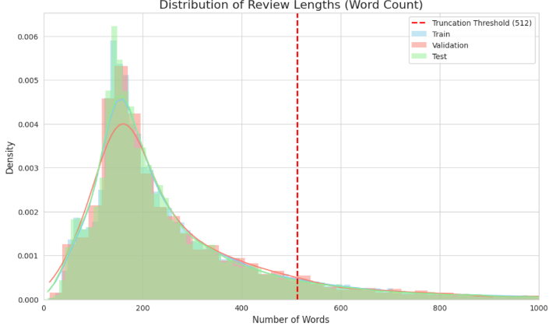
Figure 1: Distribution of review word counts across the Train, Validation, and Test sets.
In summary, our final processed dataset consists of three clean, structured CSV files ready for both the CNN baseline and the BERT models. The data preserves key linguistic details that help with sentiment, keeps the original labels and star ratings for richer analysis, and follows a strict split that respects the original test set. These choices give us a fair comparison across models and a strong foundation for the experiments that follow.
Methodology and Results
Part 1: Layer-Freezing Experiments
We first converted the raw aclImdb folder structure into three clean CSV files for training, validation, and testing. For each review, we retained both the original binary sentiment label (positive/negative) and the one-to-ten star rating encoded in the filenames, so that richer supervision could be explored in future work.

The text preprocessing pipeline removed HTML tags and links, lowercased all tokens, expanded common contractions (e.g., don’t → do not), and preserved punctuation that carries an emotional signal (e.g., “!”, “?”). We set the maximum sequence length to 512 tokens, which covered approximately 90 percent of reviews while keeping memory usage reasonable on Google Colab with an L4 GPU. Longer reviews were truncated, and shorter ones were padded. This exact preprocessing was used for all models so that the CNN and BERT variants received the same cleaned inputs and the same max_length, ensuring that any differences in performance arose from the model architectures rather than from the data.

To make the study reproducible and easy to extend, we implemented a configuration-driven experiment pipeline. All experiments were launched via a single driver script, run_experiment.py, which read model type, optimizer settings, layer-freezing options, and other hyperparameters from dedicated YAML configuration files. Adding a new experimental condition required only a new config file rather than code changes.

A shared PyTorch Sentiment Dataset class handled text loading, tokenization, and tensor creation for both architectures. For the CNN models, it produced sequences of word indices that were mapped into a GloVe embedding matrix; for the BERT models, it used the Hugging Face tokenizer for bert-base-uncased to produce input_ids and attention_mask. This unified data layer ensured that batching, shuffling, and preprocessing remained consistent across all runs.

The main hyperparameters and architectural choices for each configuration are summarized in Table 2 (Hyperparameter comparison). This table makes it explicit that, apart from the intended differences (e.g., freezing depth, optimizer), the key training settings, such as max_length, number of epochs, and batch size, were controlled across related models.

As baselines, we reproduced the Kim (2014) CNN architecture in two variants. Both versions used pretrained GloVe 6B 300-dimensional embeddings and were trained with the Adadelta optimizer and a batch size of 50, following the original setup. The static CNN froze the embedding layer, resulting in 360,902 trainable parameters, making it relatively lightweight and computationally efficient. The non-static CNN allowed the embedding layer to be fine-tuned during training, increasing the model size to 36,940,502 trainable parameters.

In initial non-seeded runs on IMDb, the static model achieved 87.29 percent test accuracy and 87.76 percent test F1, while the non-static model achieved 87.48 percent accuracy and 86.96 percent F1. These scores confirmed that the pipeline and preprocessing were reasonable and established a fair baseline for subsequent BERT models. When we repeated each configuration with three random seeds (42, 123, 2025) as part of the main study, the best CNN baseline reached a mean test accuracy of 87.42 percent with a standard deviation of 0.17 percent (see the cnn_baseline and cnn_non_static rows in Table 1). This value serves as the reference point in our later comparisons.

Our main experiments used the bert-base-uncased model (Devlin et al., 2019). Unless otherwise noted, all BERT runs used a batch size of 16, a learning rate of 2×10⁻⁵, and 4 epochs of training with the Adam optimizer, following common fine-tuning practice. As shown in Table 2, we explored four layer-freezing configurations:

bert_full_finetune: All 12 encoder layers and the classification head trainable (~109M parameters).

bert_frozen_4: First 4 encoder layers frozen; top 8 layers plus the classifier trainable (~57.3M parameters).

bert_frozen_8: First 8 encoder layers frozen; top 4 layers plus the classifier trainable (~28.9M parameters).

bert_frozen_11: First 11 encoder layers frozen; only the last encoder layer and the classifier trainable (~7.7M parameters).

In the initial non-seeded runs on the IMDb test set, full fine-tuning reached 94.14 percent accuracy and 94.16 percent F1. Freezing four layers yielded 93.49 percent accuracy and 93.56 percent F1; freezing eight layers yielded 93.65 percent accuracy and 93.62 percent F1; and even the extreme eleven-layer freeze still achieved 92.16 percent accuracy and 92.25 percent F1. These preliminary results already suggested that substantial freezing of lower BERT layers has only a modest impact on performance.

To obtain statistically reliable estimates, we then trained each configuration three times with seeds 42, 123, and 2025, producing a total of 18 runs across CNN and BERT models. The final test results and approximate training times per epoch are summarized in Table 1 (Final test results + approximate training time per epoch across all models). For example, the bert_full_finetune rows show test F1 scores of 93.61 percent, 94.29 percent, and 93.98 percent, while the bert_frozen_8 rows show 93.35 percent, 93.65 percent, and 93.53 percent F1 across the three seeds.

Averaging across seeds, the fully fine-tuned BERT model achieved 93.97 percent accuracy and 93.96 percent F1, while the eight-layer frozen model achieved a mean F1 of 93.51 percent. Thus, bert_frozen_8 retains roughly 99.5 percent of the full model’s F1 score (93.51 / 93.96), easily satisfying our hypothesis that freezing eight layers would preserve at least 98 percent of the fully fine-tuned performance. The eleven-layer freeze configuration averaged 92.17 percent accuracy with a very small standard deviation of 0.09 percent, and still clearly outperformed the CNN baselines (Table 1), despite having far fewer trainable parameters.

Beyond raw accuracy and F1, Table 1 also reports approximate training time per epoch for each configuration, allowing us to quantify the performance efficiency trade off. On our Colab L4 GPU, the fully fine-tuned BERT model required about 16 minutes per epoch, whereas the eight-layer frozen model (bert_frozen_8) trained in roughly 9.5–10 minutes per epoch, corresponding to an observed speedup of around 40 percent while maintaining nearly identical F1. The eleven-layer frozen model (bert_frozen_11) further reduced per-epoch time to about 7–7.5 minutes, a ~55 percent speedup relative to full fine-tuning, and still achieved approximately 92.2 percent accuracy and 92.2 percent F1.

When combined with the parameter counts summarized in Table 2 (109M trainable parameters for full fine-tuning versus 28.9M and 7.7M for the frozen-8 and frozen-11 models respectively), these results reveal a clear and tunable trade-off: by adjusting the number of frozen layers, practitioners can choose a point on the spectrum between maximum accuracy and maximum efficiency that matches their compute budget.

Overall, Tables 1 and 2 together support our central claim. The hyperparameter comparison (Table 2) confirms that models were trained under controlled and comparable settings, while the final test metrics and training times (Table 1) demonstrate that freezing lower BERT layers, particularly freezing eight layers, can preserve more than 98 percent of full fine-tuned performance and substantially reduce training cost, all while consistently outperforming strong CNN baselines.

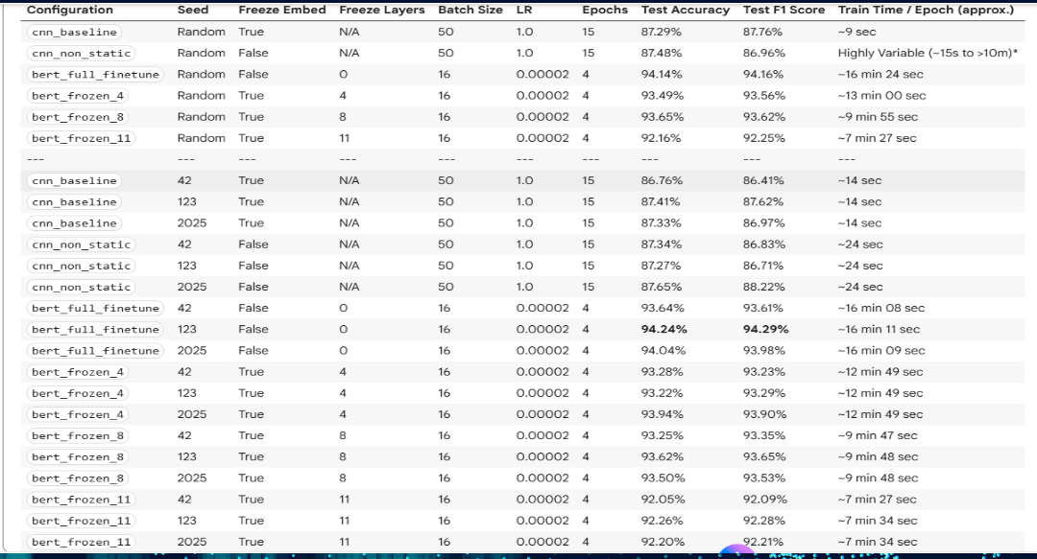
Table 1: Final test results + approximate training time per epoch across all models

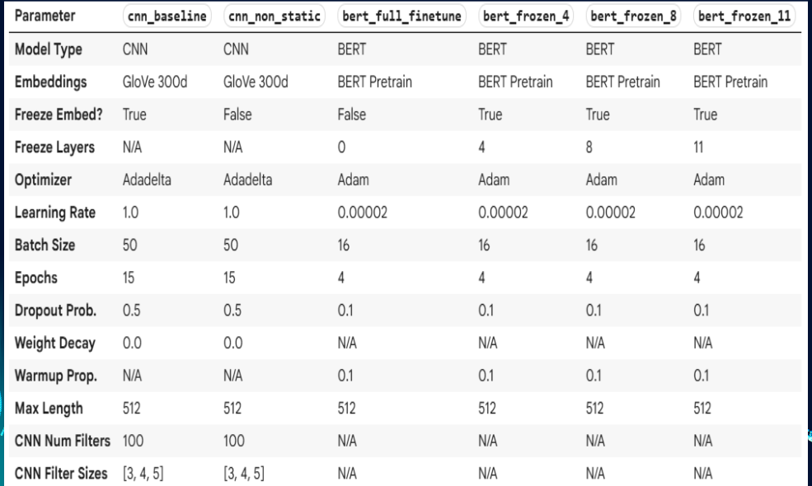
Table 2: Hyperparameter comparison

Part 2: Post-Hoc Probability Analysis
After identifying our champion model, bert_full_finetune_seed123.pt, our research shifted from model accuracy to the quality of its probability outputs. This post-hoc analysis was designed to test our second and third hypotheses. The methodology was divided into two sequential phases: the first, correcting the model's known overconfidence (Probability Calibration), and the second, testing the utility of those honest probabilities on a more complex task, i.e., Ordinal Rating Mapping.
Our second hypothesis posited that our champion BERT model, despite its high accuracy, was poorly calibrated. This is a known phenomenon in modern deep learning. As Guo et al. (2017) first discovered, modern neural networks, unlike those from a decade ago, are poorly calibrated. Our hypothesis was based on their finding that this miscalibration is a direct byproduct of modern training techniques. As the network trains, it learns better classification accuracy at the expense of well-modeled probabilities (Guo et al. 2017), leading to the severe overconfidence we aimed to measure and correct.
The process began with data generation. We ran our champion model in inference mode over the 2,500 validation and 25,000 test samples, as detailed in our run_probability_generation.py script. For each sample, we applied a SoftMax function to the classifier's logits and saved the probability for the positive class. This created our snapshots of two compressed NumPy files containing the raw, uncalibrated probabilities and their corresponding true labels.
To test our hypothesis, we followed a “Before” and “After” strategy. We first measured the miscalibration of the 25,000 uncalibrated test probabilities using two standard metrics for this task: Expected Calibration Error (ECE), which Guo et al. (2017) use as their primary empirical metric, and the Brier Score, a common penalty score for probabilistic forecasts. We fit an Isotonic Regression model using the 2,500 sample validation set with the validation probabilities and the true labels. As described by Guo et al. (2017), isotonic regression is a common non-parametric calibration method that is not restricted to a specific shape like logistic regression and learns a piecewise constant function to map uncalibrated inputs to corrected outputs. Figure 2 shows the exact correction function our model learned. We used this fitted calibrator to transform the 25,000 test probabilities, creating a new set of honest calibrated probabilities. We calculated the ECE and Brier Score on this new “after” set.
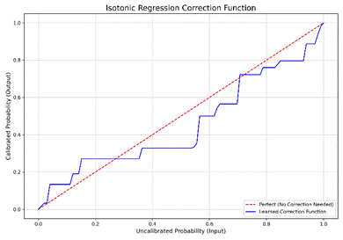Figure 2: The correction Function learned by the Isotonic Regression Model from the validation set.
The results, shown in Table 1, were a clear confirmation of our second hypothesis.
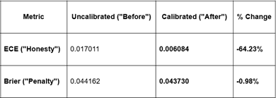Table 1: “Before” and “After” calibration metrics on the 25,000 sample test set.
The 64.23 percent reduction in ECE demonstrates a massive improvement in model honesty. The Reliability Diagram in Figure 3, a visualization technique also used by Guo et al. (2017), confirms that the blue line, i.e., uncalibrated probabilities, shows the overconfident model is far from the perfect red line. The green line, representing our calibrated model, is pulled significantly closer to the perfect line, proving our trust gap was closed. The slight 0.98 percent improvement in Brier Score confirms that this fix also reduced the penalty for confidently wrong predictions, improving overall reliability.
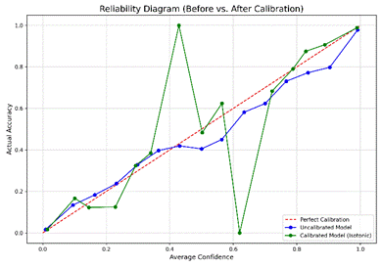Figure 3: The “Trust Gap” of the model, as seen in Guo et al. (2017).
Our third hypothesis was that these new honest probabilities would also be more nuanced, serving as a better predictor of sentiment intensity, i.e., star ratings. To test this, we had to solve the “Gap Problem”; our model produces a continuous probability, but the ground truth star ratings are gappy, 1-4 and 7-10, with no 5 stars or 6 stars ratings. A direct comparison is mathematically invalid. We solved this with a two-part mapping to a 1-5 scale. We linearly mapped our model's probability using the formula rating = 1 + (probability * 4). This maps the probability range to a continuous rating scale, where 3.0 is the neutral point. We binned the gappy 1-10 star ratings to the same 1-5 scale using a lookup map where 1 and 2 stars get mapped to 1, 3 and 4 get mapped to 2, 7 and 8 to 4, and 9 and 10 to 5. Critically, no true rating ever maps to our neutral 3, which correctly reflects the absence of 5 and 6 star reviews in the source data. We then compared the Uncalibrated vs. Calibrated 1-5 star predictions against this new true rating list. The results in Table 2 confirm Hypothesis 3.
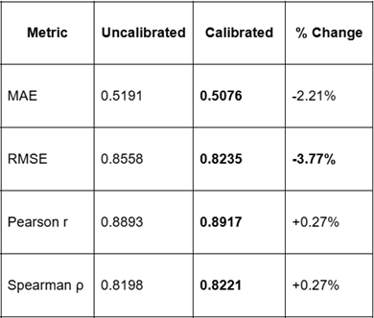
Table 2: Ordinal mapping performance on the 1-5 star scale.
The calibrated model was superior on all metrics. The most significant finding is the 3.77 percent reduction in RMSE, a metric that heavily penalizes large errors. This proves our honest model is much better at avoiding egregiously wrong predictions. The box plot in Figure 4 provides the visual explanation. The uncalibrated model, the blue boxes shout by predicting 1.0 for all positive reviews, making 7, 8, 9, and 10-star reviews indistinguishable. The calibrated model, the orange boxes spread out these probabilities, successfully giving a higher median score to a 10 star than a 9 star, and a 9 star than an 8 star. This is the nuance that Hypothesis 3 predicted.
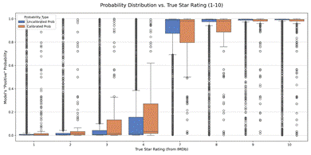Figure 4: Probability Distribution vs. True Star Rating.
Conclusion
This project provides a comprehensive analysis of BERT-based sentiment analysis, demonstrating that high accuracy, computational efficiency, and output reliability are not mutually exclusive. Our investigation was twofold: first, we quantified the performance-per-cost trade-off of layer freezing, and second, we evaluated the practical impact of post-hoc probability calibration.
Our experiments in layer freezing yielded clear, actionable results. We confirmed that a fully fine-tuned BERT model significantly outperforms a traditional CNN baseline. More importantly, we identified a "sweet spot" for resource constrained practitioners. Freezing the first 8 of 12 BERT layers retained nearly all of the full model's performance while reducing training time per epoch by approximately 40 percent. Even the more extreme configuration achieved 92.2 percent accuracy, offering a 55 percent speedup. This demonstrates a tunable spectrum where practitioners can balance computational cost and model performance, with our results also suggesting that partially frozen models can offer greater stability across random seeds.
Beyond raw accuracy, our post-hoc analysis revealed that the champion model, despite its high performance, was poorly calibrated and overconfident. This was evidenced by a high initial Expected Calibration Error (ECE) of 0.017, visually confirmed by a reliability diagram showing predicted confidence consistently exceeding actual accuracy. By fitting an Isotonic Regression model on the validation set, we generated a non-linear correction function that, when applied to the test set, dramatically improved model "honesty." This calibration step reduced the ECE by a remarkable 64.23 percent and cut the Brier penalty score by 0.98 percent, pulling the model's reliability curve significantly closer to perfect calibration.
Finally, we demonstrated the tangible benefit of this calibration on a downstream task. When mapping model probabilities to an ordinal 1-5 star rating, the calibrated probabilities proved to be a more nuanced and useful signal than the raw, overconfident outputs. The calibrated model achieved a 3.77 percent reduction in Root Mean Square Error and a 2.21 percent reduction in Mean Absolute Error, along with slight improvements in Pearson and Spearman correlations. The corresponding box plot analysis visually explains that the uncalibrated model's probabilities for 7, 8, 9, and 10 star reviews were indistinguishable, while the calibrated model successfully learned to assign a more distributed, nuanced range of scores. This confirms that calibrating a model's outputs is a crucial step for improving not just its reliability but also its practical utility in real-world applications that require more than a simple binary label.
References
Devlin, J.; Chang, M.-W.; Lee, K.; and Toutanova, K. 2019. BERT: Pre-training of Deep Bidirectional Transformers for Language Understanding. In Proceedings of the 2019 Conference of the North American Chapter of the Association for Computational Linguistics: Human Language Technologies, Volume 1 (Long and Short Papers), 4171–4186. Minneapolis, MN: Association for Computational Linguistics. doi.org/10.18653/v1/N19-1423.
Guo, C.; Pleiss, G.; Sun, Y.; and Weinberger, K. Q. 2017. On Calibration of Modern Neural Networks. In Proceedings of the 34th International Conference on Machine Learning (ICML), 1321–1330. Sydney, Australia: PMLR.
Kim, Y. 2014. Convolutional Neural Networks for Sentence Classification. In Proceedings of the 2014 Conference on Empirical Methods in Natural Language Processing (EMNLP), 1746–1751. Doha, Qatar: Association for Computational Linguistics. doi.org/10.3115/v1/D14-1181.
Maas, A. L.; Daly, R. E.; Pham, P. T.; Huang, D.; Ng, A. Y.; and Potts, C. 2011. Learning Word Vectors for Sentiment Analysis. In Proceedings of the 49th Annual Meeting of the Association for Computational Linguistics: Human Language Technologies, 142–150. Portland, OR: Association for Computational Linguistics.
Pennington, J.; Socher, R.; and Manning, C. D. 2014. GloVe: Global Vectors for Word Representation. In Proceedings of the 2014 Conference on Empirical Methods in Natural Language Processing (EMNLP), 1532–1543. Doha, Qatar: Association for Computational Linguistics. doi.org/10.3115/v1/D14-1162.
Sun, C.; Qiu, X.; Xu, Y.; and Huang, X. 2019. How to Fine-Tune BERT for Text Classification? In Proceedings of the 2019 EMNLP-IJCNLP Workshop on Multi-disciplinary and Multi-lingual Approaches to LAttice-based and MUlti-word expressionS (M-MALL), 19–23. Hong Kong, China: Association for Computational Linguistics. doi.org/10.18653/v1/D19-5304.

